Book Review
Directions:
A critical book review is a thoughtful discussion of a text's contents, strengths, and limitations. A book review should reflect your capacity to read critically and to evaluate an author's arguments and evidence. You will be composing a book review on what you read over the course of two quarters. You will write your review on a blank sheet of paper in 10-15 sentences. You will also have some type of illustration that accompanies your review. Do not give away the end of what you read; rather, give information so someone could be informed if he/she would like to read that book. The following rubric will be used:

RUBRIC
10-15 sentence summary/review of book is written ___________/15
Some type of illustration __________ /10
Conventions (no grammar errors, spelling, etc.) ___________/5
TOTAL: __________/30

Teacher Comments:

EXAMPLE

Get Shorty by Elmore Leonard (1990)

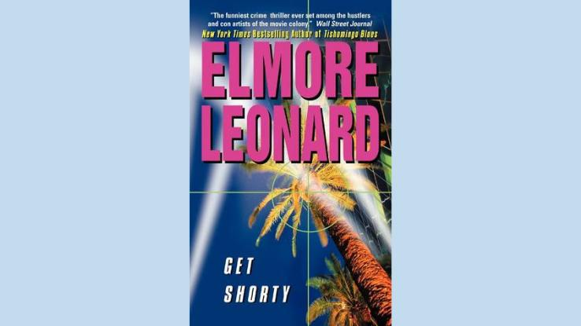

Photo Courtesy: Goodreads

Small-time Miami loan shark Chili Palmer travels to Las Vegas, hoping to get a debt paid, and ends up in Los Angeles, where he learns about the movie-making business and how to become a producer. Set in Hollywood in 1990, this California classic masterfully blends suspense, thrills, humor and even the slightest hint of a Western.
This story is so quintessentially Hollywood that there’s a 1995 movie adaptation starring John Travolta and a 2017 TV show with Chris O’Dowd, but you should definitely start with the Elmore Leonard novel.

